28.55: a) If the magnetic field at point P is zero, then from Figure (28.46) the current  must be out of the page, in order to cancel the field from . Also:
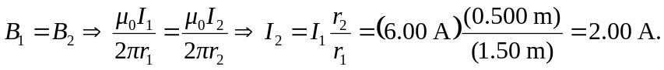
b) Given the currents, the field at Q points to the right and has magnitude
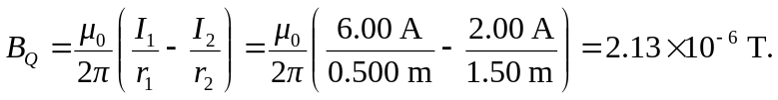
c) The magnitude of the field at S is given by the sum of the squares of the two fields because they are at right angles. So:

